

Archivist

Annual Report

2007-2008

OBJECTIVES:
- Make timely deposits of materials as received from the membership to the Reuther Library of Labor and Urban Affairs. To make at least one deposit totaling at least1 linear foot.
- Seek out archival material which is lacking or will enhance the collection
- Keep the membership aware of the material at the Reuther Library and its availability. To publish/post information about the archives to membership
- Publicize the material in the Reuther Library to appropriate non-MDMLG groups and individuals; Maintain contact with the archivist responsible for the MDMLG materials at the Reuther Library.
- To maintain contact with the archivist responsible for the MDMLG material at the Reuther Library. To arrange for at least one visit during the year and to investigate developing current finding aids for the collection

ACCOMPLISHMENTS:
- Continued discussions with Walter P. Reuther Library staff
- Confirmed 2007-2008 service charges which remained the same.
- Continued discussion of further processing and continued development of finding aids – on going.

__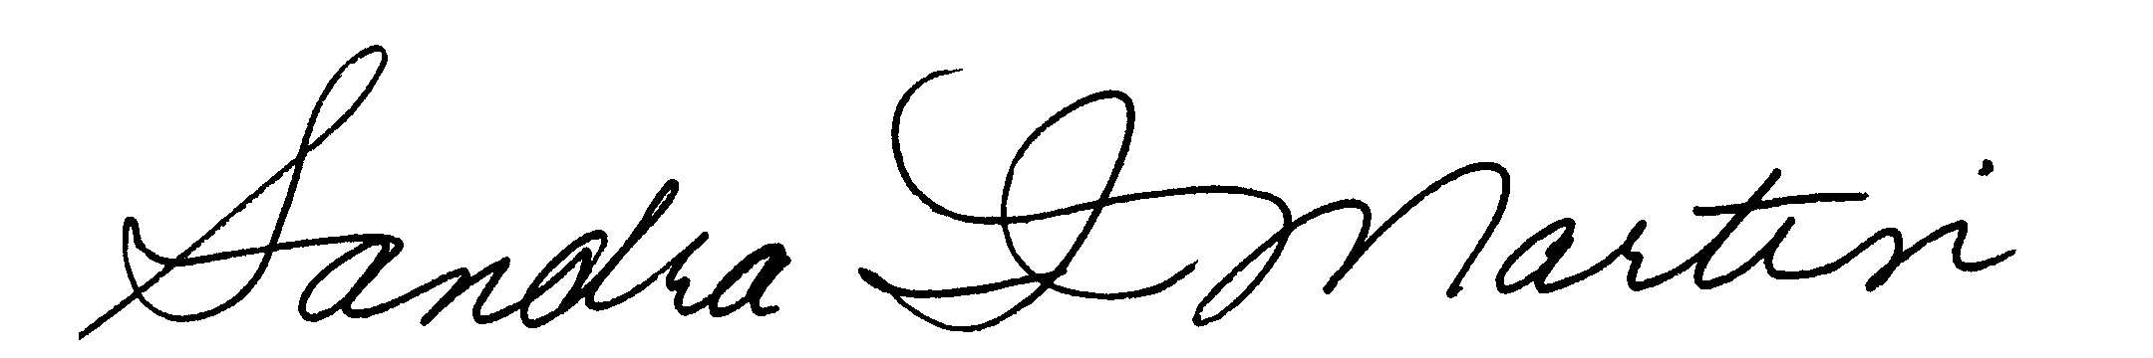_______ April 30, 2008
Sandra I. Martin, ARCHIVIST DATE

